A2263-Afr-D R Congo-Songye Statue-Scarified face-Early 20th c

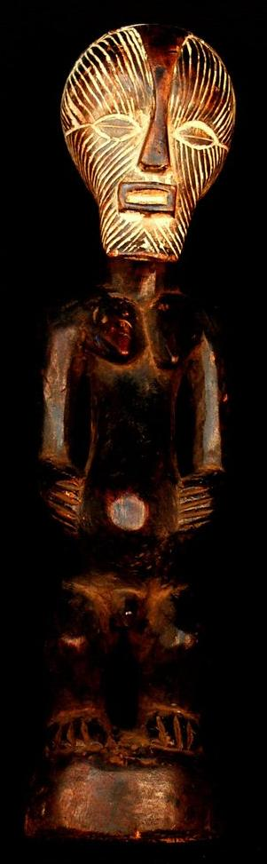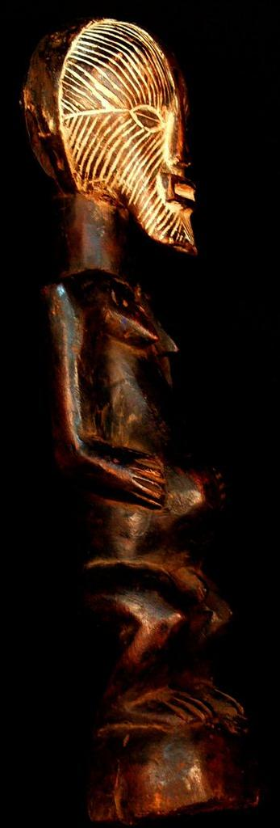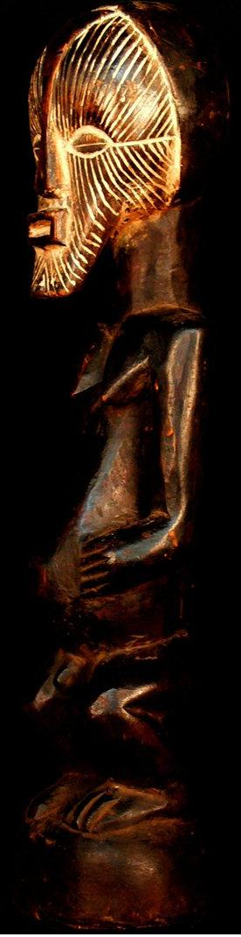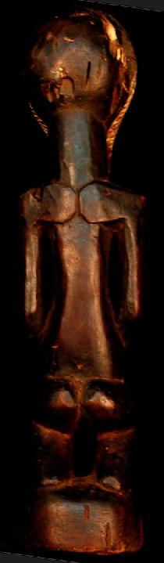

Case No.: African Masks

Accession No. A2263

Formal Label: Afr-D R Congo-Songye Statue-Scarified face-Early 20th c

**Display Description:**

The Songye sculptor was also a shaman or diviner (*nganga*)  who was unrestrained by staying with certain sculptural formulae like other groups in the D R Congo like the Kongo. Therefore, Songye artists were free to imagine the variations of the accepted sculptural grammar. A client commissioning a figure would describe the circumstances of his or her need (perhaps from a dream or a mystical encounter with a spirit) and then would allow the shaman-artist to design and execute the shape of a sculpture from a block of wood. This process of forming the shape of the spirit within the wood was itself a mystical encounter with the spirit in the wood and in the mind of the Shaman-sculptor. The result was a spiritually powerful being, with a threatening demeanor and full of purpose in demanding of its audience an undivided.

This statue was sculpted probably in northern Milembwe and is characterized by a peculiar expression of its rectangular mouth, a broad band separating the hair on the two sides of the cranium indicating that the area had been rigorously shaved, total lineal scarification of the face that flows seamlessly into a beard, and partly closed eyes suggesting a meditative posture -- all attest to the spiritual powers evoked by this statue of an ancestor as an individual spirit ready to intervene in the affairs of men and women today. The gesture of the hands on the belly on either side of the everted navel (which symbolizes the lineage of clan) evokes a power of protection. The peculiar rectangular shape of the mouth is poised, ready to deliver important communications immediately.   
Songye figure, Democratic Republic of the Congo  
  
François Neyt attributes the Songye figure from the Malcolm collection to the northern Milembwe, Beland and Eki stylistic region. Songye sculptors from this artistic tradition paid special attention to the carving of the mouth. The broken line of the head of the hair, the closed upper eyelids, and the curvilinear base are all characteristic of a small corpus of sculptures which are attributable to Eki or Kibeshi in the southwest, near Lubanga. Kasai "(Neyt, Neyt, Songye, The dreaded Songye statuary of Central Africa, 2004, 313). The most accomplished works of this corpus are in private hands: the figure from the Malcolm collection; the figure from the collection of Baudouin de Grunne; and finally, a figure which once belonged to Christian Duponcheel (ibid., Nos. 30 and 32).  
  
The sculptural quality of the figure, its iron collar, and the horn which is one of the best of the world. the diviner, or nganga, who used his knowledge of cosmic energies to transform the figure into an active force.  
  
The magico-religious powers and strength of this figure are reflected in its form, which is frontal, symmetrical, and ready to intervene. The hands on the stomach symbolizes the figure's protective power over the clan and lineage. The sense of vigor is enhanced by the architectural structure, which emphasizes the angular volumes of the planed surfaces. The half-closed eyes suggest the vigilance, wisdom and serenity that were the prerogatives of the honored ancestor. The sensory features are subtly accentuated: the mouth, to deliver important messages; the nose, to the spirits which enter and exit through breath; and the ears, which catch all words, whether audible or inaudible. The sculpture is an efficient mediator between men and the spirits of the ancestors capable of protecting an entire community.

Accession Number:

**LC Classification:**

Date or Time Horizon:

Geographical Area:

**Map:**

**GPS coordinates:**

Cultural Affiliation:

Media: Wood, pigment

Dimensions: H 18.50 inches

Weight: 1.65 pounds

Condition:

Provenance:

**Discussion:**

**References:**

Neyt, François. 2004. The Songye: the formidable statuary of Central Africa

.